DATA STORY REPORT HANDOUT
PART 1: EXAMPLE REPORT — “Corporate Discounts and Profit Margin” (this is for the overall Superstore story)
Executive Summary
We analyzed 2011-2014 Superstore sales data to understand why profit margins declined despite rising sales. Our findings show that the Corporate customer segment received steep discounts throughout 2014, which significantly reduced profit margins. Although Corporate contributed strongly to total revenue, the erosion in margins offset much of this gain. The results suggest that high-volume discounts may be too generous. We recommend reevaluating discount policies for Corporate clients, particularly in high-sales regions, to restore profitability.
Context
In 2014, overall sales at Superstore increased by nearly 15% compared to the previous year, yet companywide profit margins declined. Management requested an analysis to determine which customer segment or factor was responsible for this drop. We examined sales, discounts, and profit data by customer segment.
Insight (Evidence)
The analysis revealed that the Corporate segment showed a clear pattern of high discounts and lower margins compared to the Consumer and Home Office segments. While Corporate sales increased sharply, average profit margins fell by nearly 4 percentage points. Visualizations confirmed that discount rates for Corporate customers were consistently higher across regions.
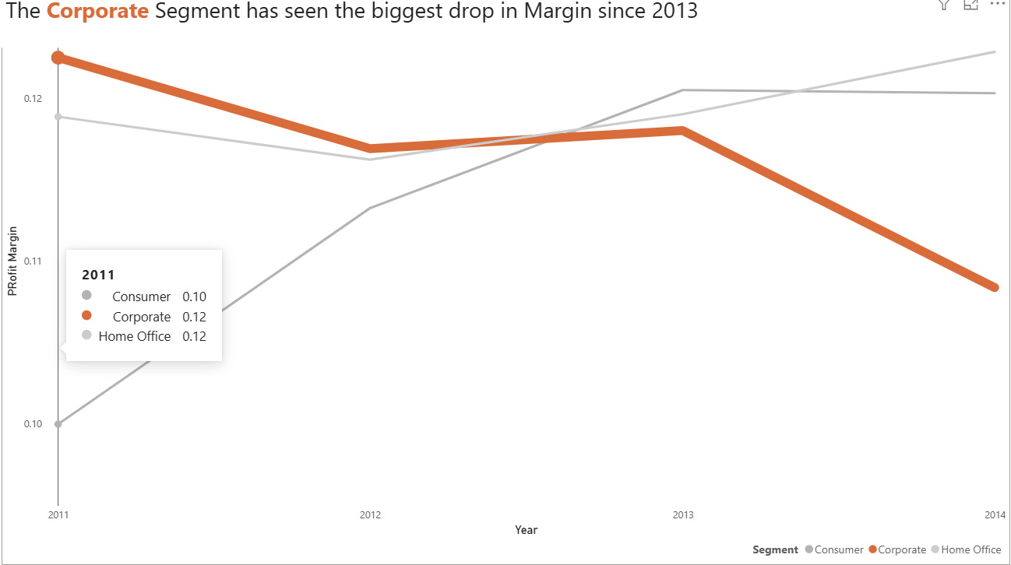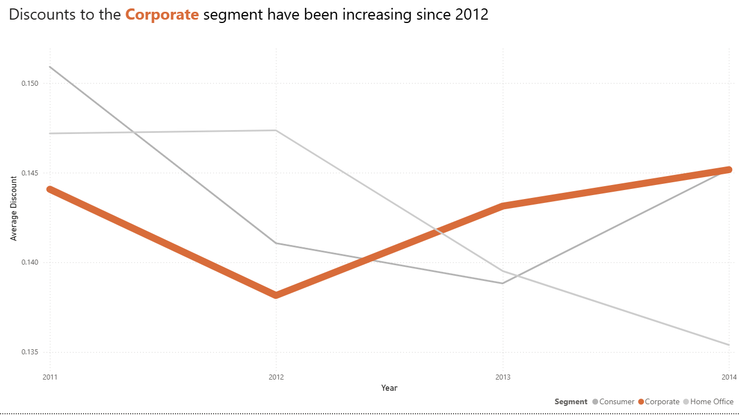
Corporate discount rates averaged 24% in 2014, compared to 15% for other segments.

Corporate margins fell by 2% since 2013

Meaning
These findings indicate that growth in Corporate sales was achieved primarily through price reductions. In other words, discounts—not organic demand—drove much of the sales increase. This pattern is not sustainable, as lower profit margin can eventually outweigh revenue gains, particularly if high-volume customers rely on discounted pricing.
Action / Recommendation
The company should conduct a focused review of discount structures for Corporate clients, beginning with regions where discounts exceed 25%. A hierarchical discount model based on order size and profitability could help balance sales growth while keeping profit margin within bounds. Management should monitor the effect of revised discount levels on overall profitability in the next quarter.

Executive Summary
We studied the Great Superstore Data to discover why the company wide profit margin has decreased from 2013 – 2014 when it has been increasing since 2011. From the deep dive it was discovered the Furniture Segment is weighed down by Tables due to high shipping costs. The costs vary per region with Southeast Asia having -35% margins on all table sales. A deeper dive showed the methods of shipping First and Second Class causes a loss and break even respectfully. From these findings the analysts recommend that the company either charges a premium for First- and Second-Class shipping or allows the analysts to continue exploring the data to possibly further explore alternative solutions.
Context
Overall, from 2011 to 2013 companywide profit margins have been increasing. Though from 2013 to 2014 the trend changed and profit margin started to decrease. Finance requested to know why the change in trend along with any possible solutions. To solve this question we used sales, shipping, and profit data.
Insight (Evidence)
From data exploration we have found that Furniture has below average profit margin with only around half as profitable as Technology and Office Supplies. Further investigation shows that the Tables subcategory has a negative profit margin meaning a loss occurs for every sale. Certain regions are less profitable than others with the Southeast Asian region having the lowest at -35%. Overall, the root cause of the low profit margins is shipping costs as tables are 30% more expensive than the next most expensive. Furthermore, first and second-class shipping cause losses or break even.
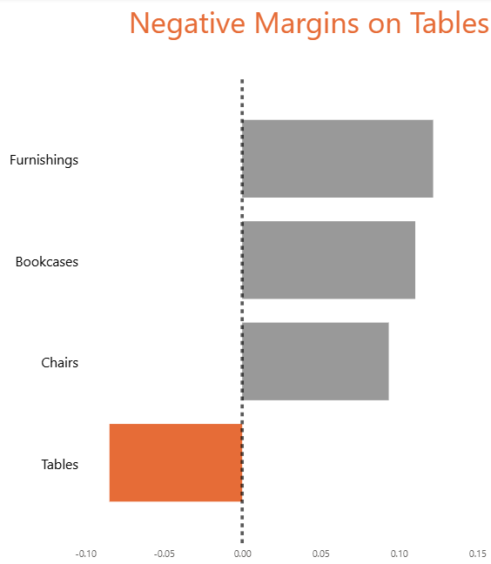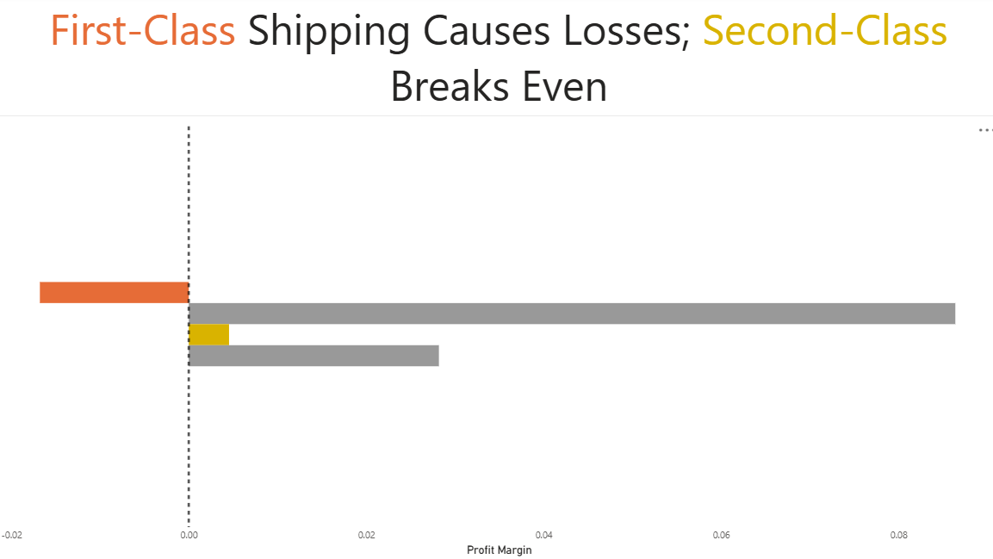
Meaning
These findings indicate that the shipping protocols currently are not sustainable for the current market. While using different modes of shipping may bring other benefits not shown in the data currently it can no longer be continued. If it is, the profit margin will continue to decrease and cause losses.
Action / Recommendation
From the information revealed through exploration the company should either charge a premium for first- and second-class shipping to ensure a profit or the analysts can continue to dig deeper and collect more data for a potentially different solution. Continuing with the current structure will only cause more losses for the company.

